PROG2500 – Final Group Project

By: Ryan Osborne, Bryce MacLeod, and Alex Reynolds

# Project Proposal

## Project Group Overview

Our final group project consists of Ryan Osborne, Bryce MacLeod and Alex Reynolds. The application we plan to develop will present the user with the NHL scores of the previous day as well as who scored and when.

## Project Description

Our application is a UWP App that will consume the API provided by <https://github.com/peruukki/nhl-score-api> (<https://nhl-score-api.herokuapp.com/api/scores/latest>). The API data will be held in variables that are data bound to the application. Our app will display the most recent NHL matches as a block with the team logos and the result (win/loss score). The application will also allow the user to select a match, which will expand/pop out to see the timestamps of goals, along with the scorer, shots and other information we can access from the API.

The application will asynchronously fetch data from an API that will be stored until we are ready to update each of the text display fields. The application will use data binding to update each of the text fields individually. The User can use the search box at the top to filter for a team if there are multiple playing that day and can click on a player under an active score to get their stats on the year. We will have a secondary command bar option to display the developers of the app to the user in a text dialogue box.

## Project Wireframe

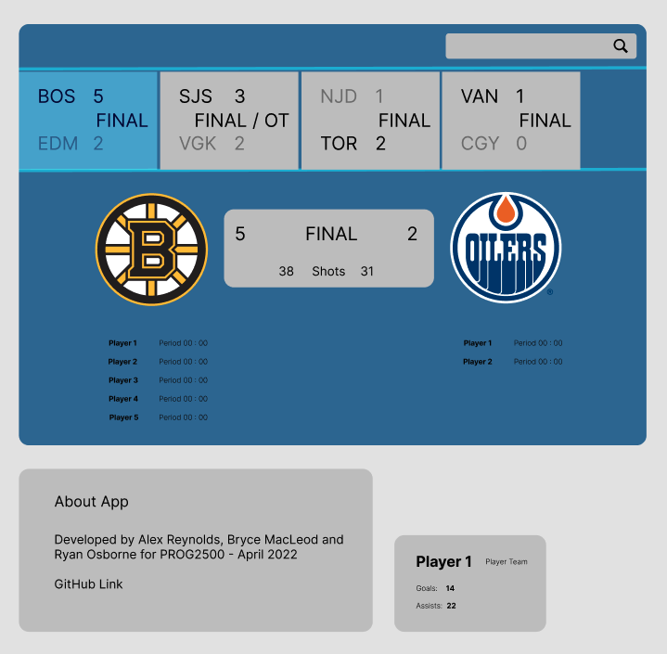

## Project Workplan

March 29th - 31st – complete and submit project proposal

April 5th – April 12th – Build the application – see following list of tasks

April 12th – April 15th – Work on presentation and demo, peer and self-reviews.

Our group is making use of a Trello board to track progress and task management. Some of our tasks to build the application:

* Storing API data into variables. (**Alex**)
* Appropriate Model classes for holding Match, Team and Player data. (**Bryce**)
* Appropriate data binding of the variables to the UWP application. (**Bryce**)
* User control to display Match data. (**Ryan**)
* User control to display Player data. (**Alex**)
* Three application screens: A landing screen displaying the latest matches. Another page for player statistics. And a final credit page, listing team members. (**Group**)
* Search feature to limit matches to searched team name. (**Ryan**)
* Find and format necessary image files (**Ryan**)

## Presentation Speakers Notes

### The Idea

We wanted to make our final project handle data from something that was familiar to all of us. Ryan suggested we make our app display scores from NHL games and went out and found an API that could provide us with that data.

We were all familiar with apps such as the Score and TSN which show the user scores and stats from previous games so we thought it would make a fun project.

### The Design

We decided to reuse some of the components and functionality from the previous 4 assignments such as the scroll view for our horizontal scroll bar, data binding for linking the data to the xaml file and design features such as the command bar to link to other pages.

### The Journey

After we had the idea and resource to get our data, we started to set up our development environment. We were using **Visual Studio** as our IDE and **Git** as our collaboration tool/version control.

We ran into a couple problems shortly after setting up our development environment. We kept getting merge conflicts with the IDE config files which we resolved with the proper gitignore file. We ran into another big merge conflict when setting up our xaml layout and creating the model and viewmodel classes. Fortunately, we were able to resolve this by properly forking the original repository and communicating what we intended to change before we changed it.

Once we resolved these minor issues it was a matter of implementing the API call properly and populating our model and viewmodel objects.